🚗 Smart Accident Detection & Emergency Alert System

1️⃣ Project Overview
📌 Problem Statement
- Road accidents cause millions of deaths annually
- Major issue: delay in emergency response
- Victims may be unconscious → unable to call for help ❌
✅ Solution
- Detect accident using MPU6050 (acceleration + tilt)
- Fetch location via GPS (NEO-6M)
- Send alert using WiFi (ESP32) or GSM
🌍 Real-world Applications
- 🚑 Emergency systems
- 🚗 Smart vehicles
- 📦 Fleet tracking
- 🛵 Bike safety systems

2️⃣ Components Required 💡
Component | Purpose | Approx Cost (₹)
ESP32 | Main controller | 300–500
MPU6050 | Detect impact/tilt | 150
NEO-6M GPS | Get location | 250–350
GSM Module (SIM800L) (optional) | SMS alerts | 300
Buzzer | Alert sound | 30
Push Button | Cancel alert | 10
Battery + Wires | Power supply | 200
👉 Total Budget: ~ ₹1000–1500 ✅

3️⃣ Circuit Diagram 🔌
🧠 Connections Overview
📍 MPU6050 → ESP32
- VCC → 3.3V
- GND → GND
- SDA → GPIO 21
- SCL → GPIO 22
📍 GPS (NEO-6M)
- VCC → 3.3V
- GND → GND
- TX → GPIO 16
- RX → GPIO 17
📍 Buzzer

  - → GPIO 25

  - → GND
📍 Button
- One side → GPIO 26
- Other → GND

📷 Visual Idea
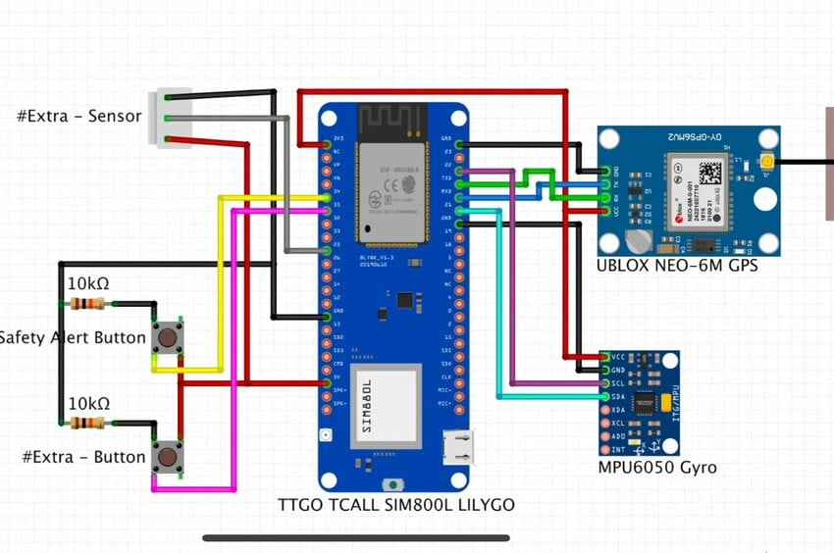
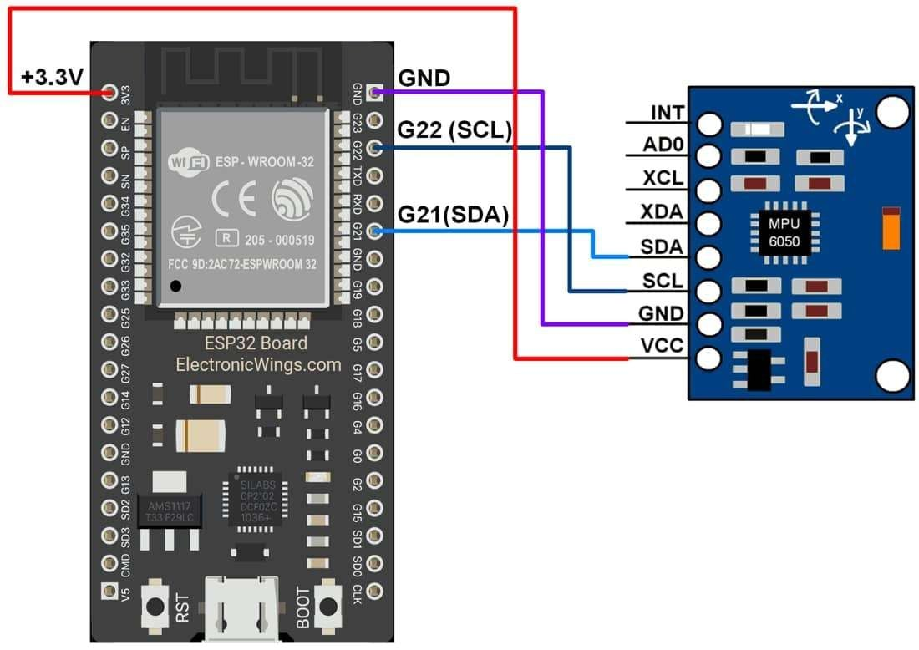
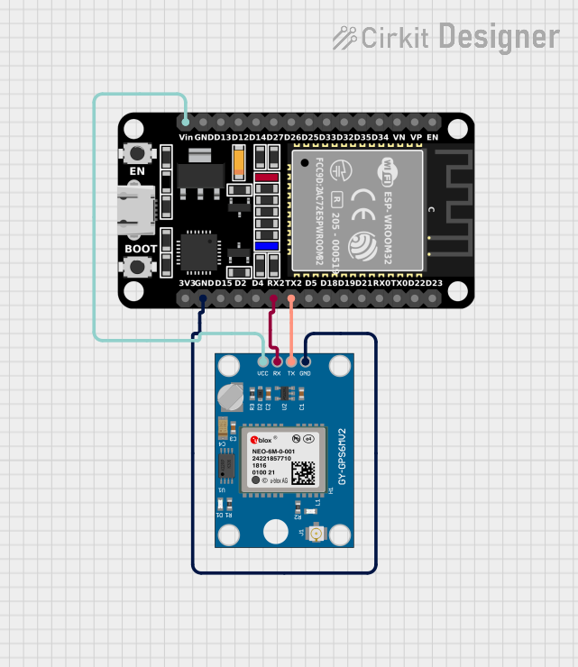
4

4️⃣ Working Principle ⚙️
🔄 Step-by-step Flow
- ESP32 reads acceleration from MPU6050
- Detects sudden impact using threshold
- Checks tilt angle (vehicle flipped?)
- If threshold exceeded:
  - Trigger buzzer 🚨
  - Wait few seconds for cancel button
- If not cancelled:
  - Get GPS location 📍
  - Send alert message 📩

🎯 Threshold Logic (Important)
If acceleration > 2.5g OR tilt angle > 60°
→ Accident detected

6️⃣ Expected Output & Demo 📱
📩 Example Message:
🚨 Accident Detected!
📍 Location: https://maps.google.com/?q=13.0827,80.2707
🔥 What Happens:
- Sudden impact → buzzer ON
- No cancel → alert sent
- GPS link opens exact location

7️⃣ Enhancements 🚀
✅ Must Add:
- 🔘 Cancel button (avoid false alerts)
- 🔊 Buzzer alert
🌐 Advanced:
- Use ThingSpeak for dashboard
- Use Blynk mobile app
🤖 AI Idea (IMPRESSIVE)
- Train model on:
  - Speed
  - Impact force
- Predict:
  - Minor / Severe accident

